**Bug Tracker**

* Bug tracker is used to assignee and track bugs in the project.
* First, we create account in Jira and create project.

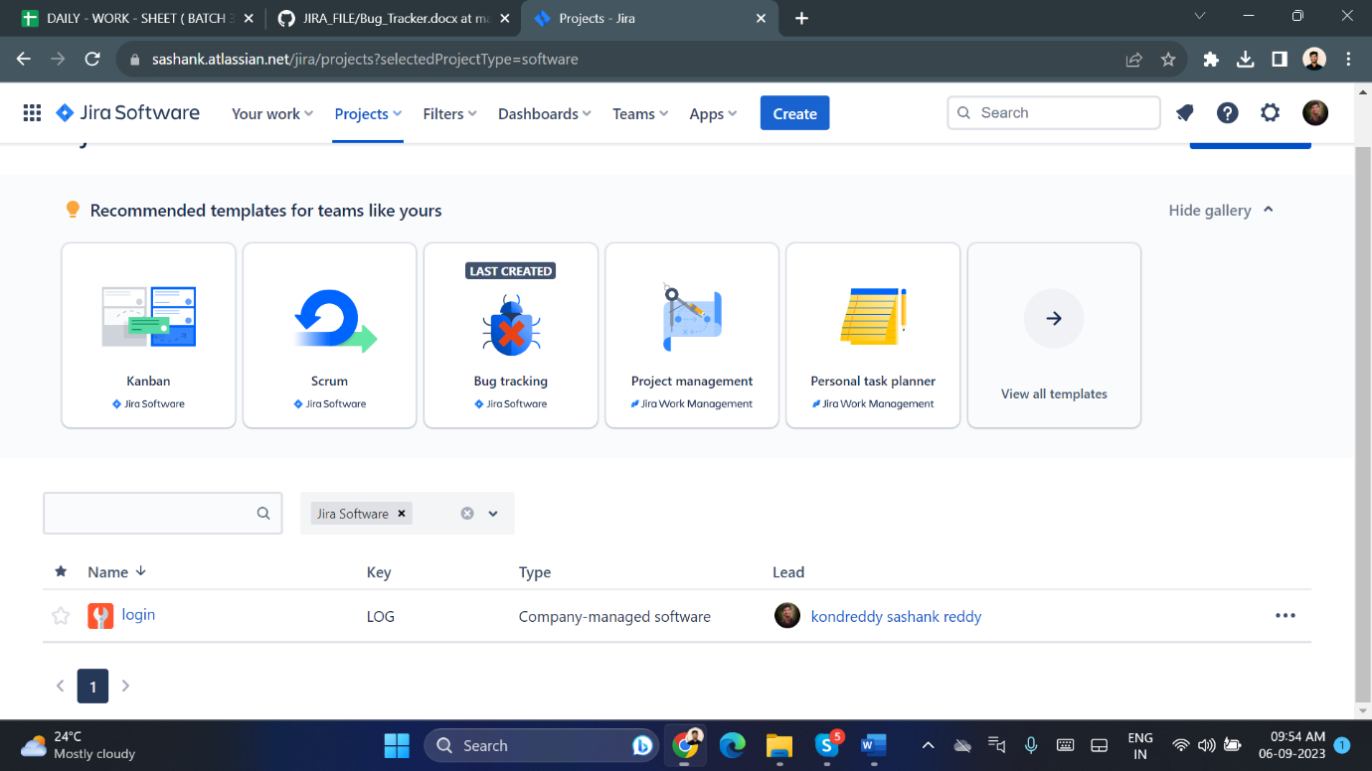

* 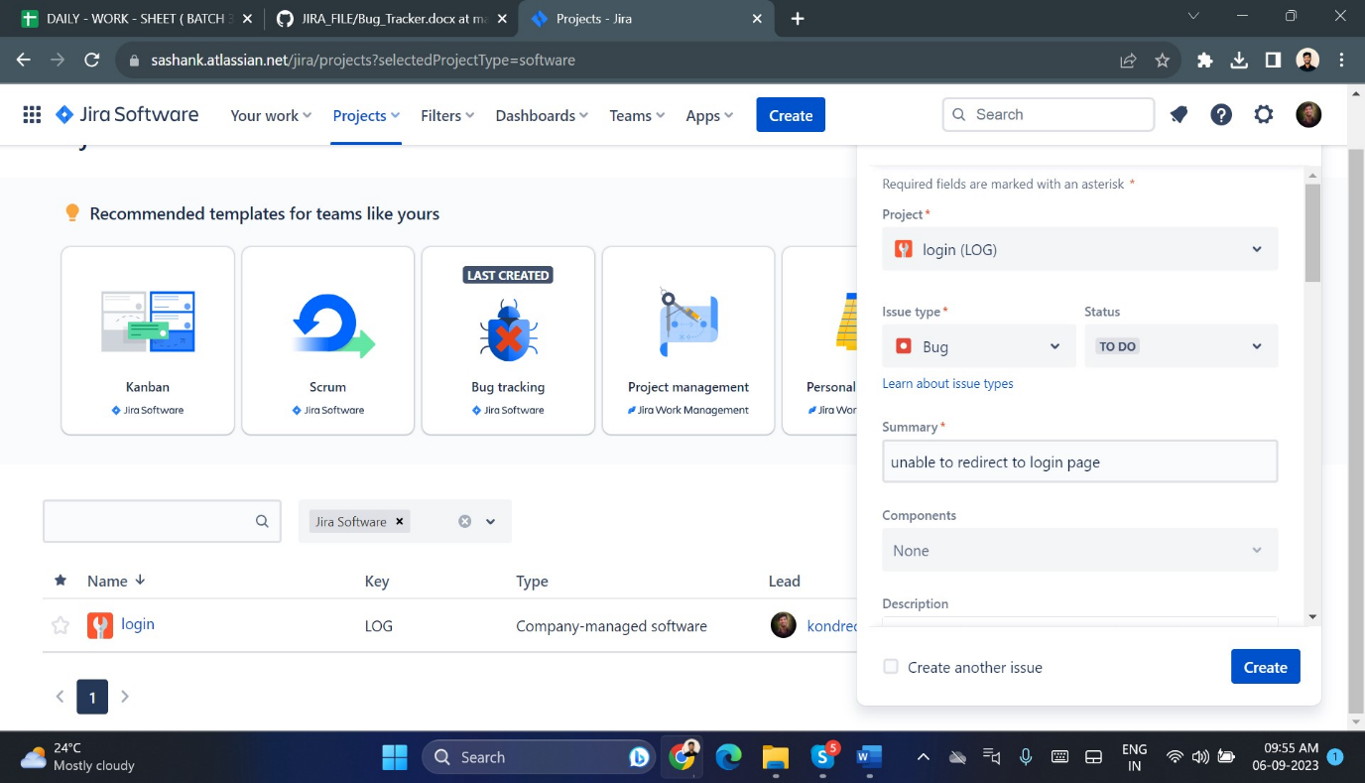After creating a project create bugs which are arrived.
* 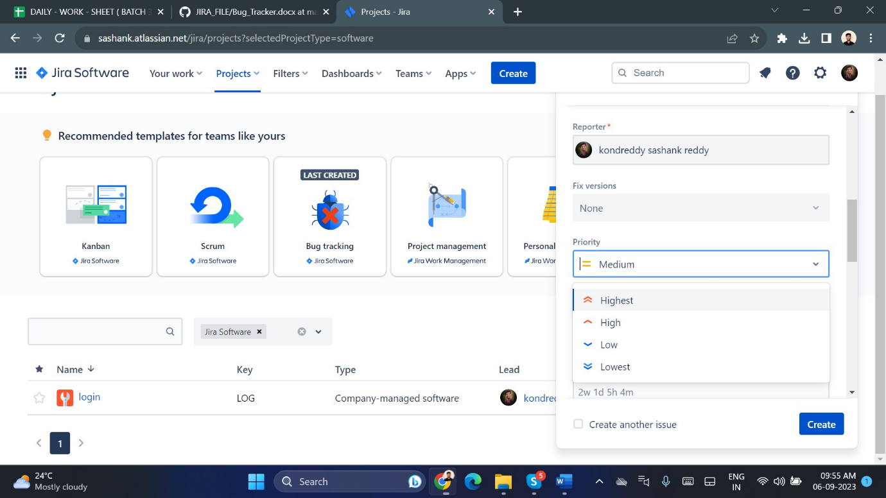After creating bugs prioritize the bugs.
* Assignee to the teammates

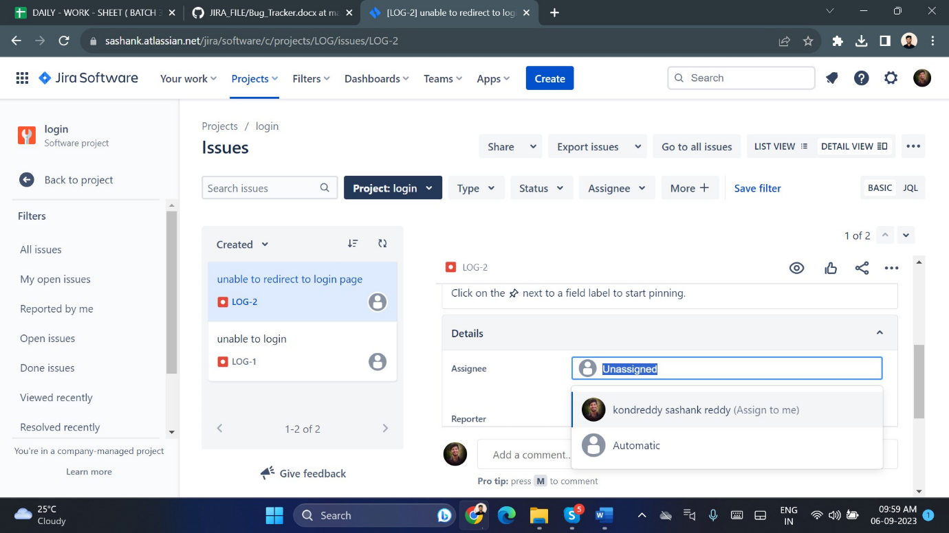

* Now teammates start working on the bugs and complete them.

